Abe Lincoln’s Hat

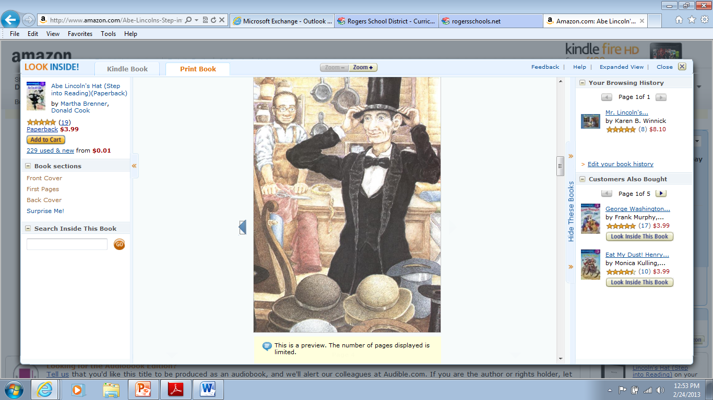

**1** Lincoln is wearing a _________.

scarf book suit dress

**2** The hats are in _________ in the store.

stacks shelves racks heads

**3** Lincoln will probably _________ a new hat.

fix purchase destroy design

**4** A person who works in a store is a...

teacher driver shopper clerk